- Open Google, Bing, and DuckDuckGo in your browser and search for 'best budget smartphones 2024'. Take screenshots of the first page of results for each search engine and note any differences in the top 3 results.
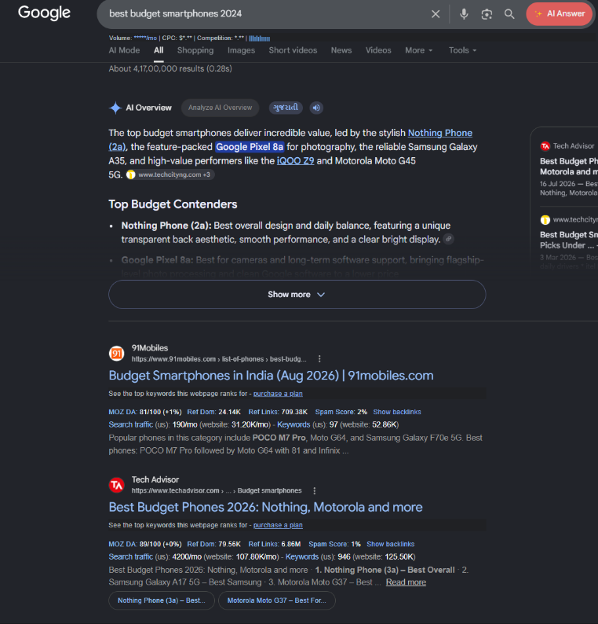

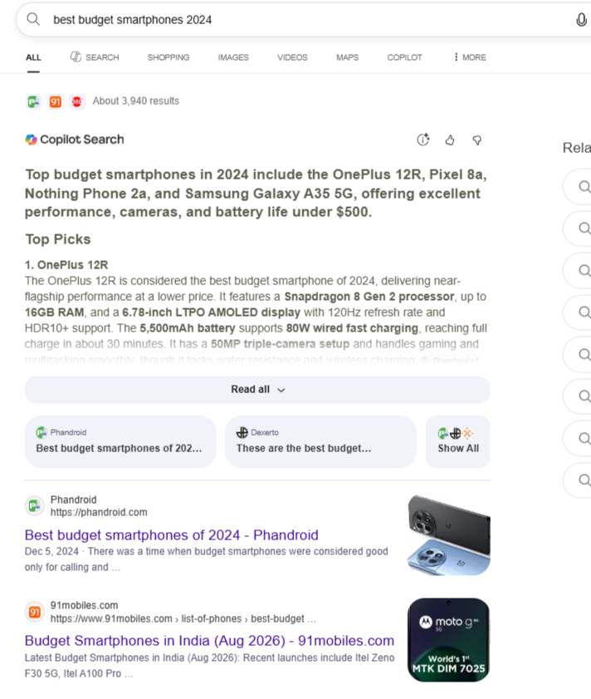
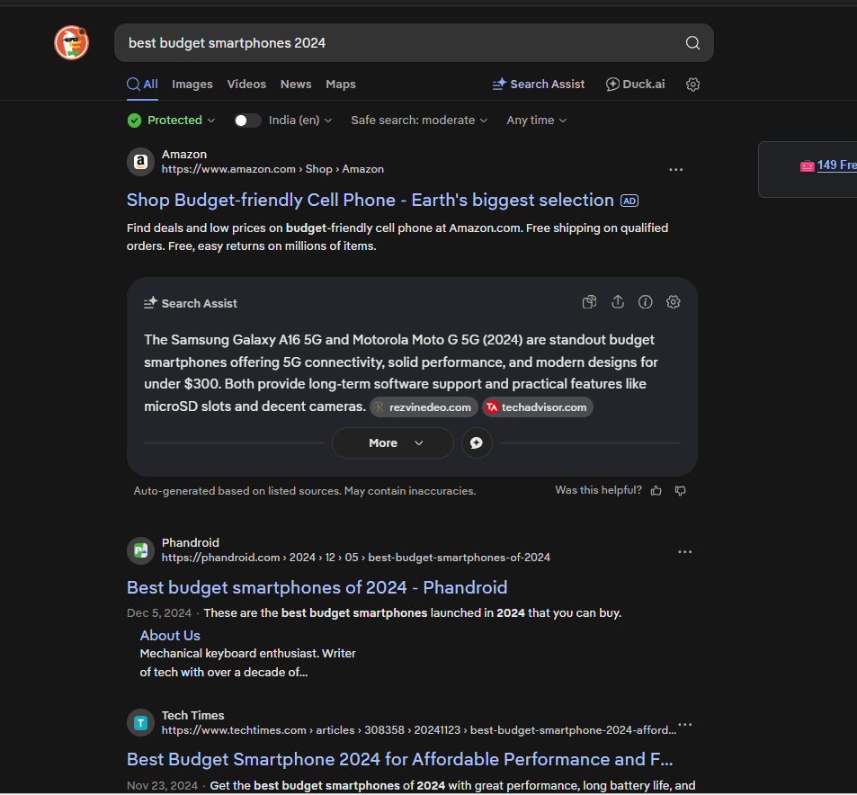
- Create a simple table in a Google Doc or Excel listing 5 popular search engines. For each, write one unique feature or reason why a user might choose it over Google.
Search Engine | Unique Feature / Why Choose It Over Google
Bing | Microsoft integration and strong AI-powered search features.
DuckDuckGo | Privacy-focused search that does not track users in the same way as Google.
Yahoo | Combines web search with news, finance, sports, and other portal services.
Brave Search | Independent search with a strong focus on privacy and less reliance on Big Tech.
Ecosia | Uses advertising revenue to support tree-planting and environmental projects.

- Write a short paragraph (4-5 lines) explaining in your own words the difference between organic results and paid results on a Google search results page. Include an example of each from a recent search you performed.
Organic results are free results that appear on Google because the website is relevant and has good SEO. Paid results are ads where businesses pay Google to show their website at the top. For example, when I searched “digital marketing agency Ahmedabad,” the results marked “Sponsored” were paid results. The normal website results below them were organic results.

- Draw a flowchart (on paper or using any online tool) that shows the 3-stage process Google uses for search: crawling, indexing, and ranking. For each stage, write 1-2 lines describing what happens.

🌐 WEBSITE
↓
┌─────────────┐
│ CRAWLING │
└─────────────┘
Google bots visit websites
and discover new/updated pages.
↓
┌─────────────┐
│ INDEXING │
└─────────────┘
Google stores and understands
the useful information from pages.
↓
┌─────────────┐
│ RANKING │
└─────────────┘
Google decides which pages
are most useful for a search.
↓
🔎 SEARCH RESULTS
- Pick any trending topic (like IPL, new movie release, or a gadget launch) and search it on Google. Identify at least 2 organic results and 2 paid results from the first page, then explain how you recognized which was which.<br><br><em><strong>Hint:</strong> Look for labels like 'Ad' or 'Sponsored' and compare their placement on the page.</em>
Ans. I searched “IPL 2026” on Google. I found these types of results:

Type | Example | How I recognized it
Organic | Google India – 4 ways fans are searching IPL 2026 | No “Sponsored” or “Ad” label; it appeared as a normal result. (blog.google)
Organic | NDTV Sports – IPL 2026 Results | Normal website listing without an ad label. (NDTV Sports)
Paid | Sponsored result 1 | Paid results have an “Sponsored”/“Ad” label and usually appear near the top.
Paid | Sponsored result 2 | It is identified by the “Sponsored”/“Ad” label rather than normal organic ranking.

Organic results are free listings that Google ranks based on relevance and SEO. Paid results are advertisements for which businesses pay Google. The easiest way to identify paid results is to look for the “Sponsored” or “Ad” label.

